**Data Structure Lab (15CSE 281)**

**Lab Sheet VIII**

**Graph (26/10/16)**

Store the following graph in adjacency matrix representation

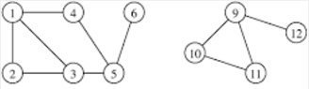

Input: vertex set and edge set

1. Display adjacency matrix A of the graph
2. Display degree of each node and its neighbor set. Eg. node 1 : degree 3 {2,3,4}
3. Display paths of length two in the graph(use adjacency matrix) . For example, 1-4-5, 1-3-5, 3-5-6...
4. Take square of adjacency matrix S and display it. check the entries [1,5],[3,6].. in S and compare it with A. Is there any difference in values?
5. Find number of paths of length 3 by taking cube of adjacency matrix